# Software Design Document

# Project Name: Programing Project 1

## Introduction

### Goals and Requirements

* The program will draw a tree and a cat using ASKII art.

### Product Scope

Briefly describe what the program will do and what the objective is.

* The program will draw a tree made from asterisks using the cout function.
* The program will print 2 new lines by calling cout a second time.
* The program will draw a cat using a variety of ASKII characters using a final cout call.

### Design Overview

### Pseudo Code

Include standard funcions

Use the std namespace

Main Function

Print Tree

Print 2 blank lines

Print Cat

Return 0

### Flow Charts

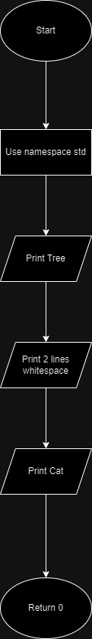

## Class Diagram

No classes used.

## User Interface

The user will only interact with the program by running it.

## Testing

I will run the program and check whether the output is correct.